===============================

Execution flow

=================================

emmediateSMSQueue

|

Step 1 Dispacher-> Parser-> TimeZone->CoreSync-> then job completed

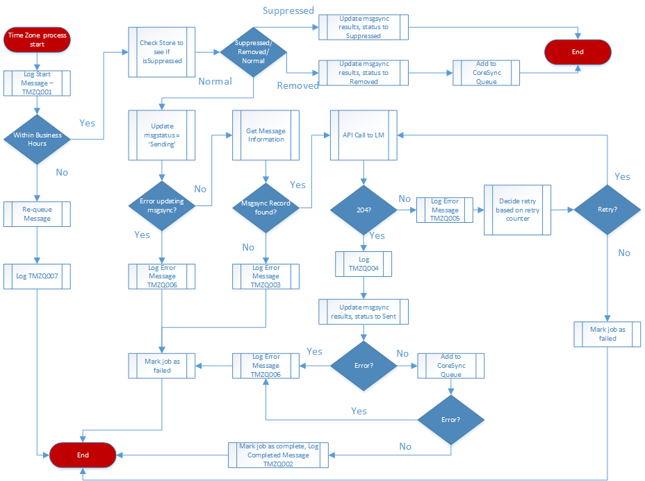

====================================

Step 1 for Dispacher

-----------------------

if Found message in NEW status then Marking message as Queued for Parsing and Parser will call and Dispatcher completed

------------------------

Step 2 Start parsing the SMS

-------------------------

Decision to call checkSmsIdOrICR and checkSmsIdOrICR

after SMS parsed Updated the SMS record with status Queued for Sending and SMS body parsed and Adding SMS to timezone queue

--------------------------

Step 3 Received message in TimeZoneQueue

--------------------------

Connected to store table and find store is suppressed or not

*if store is not suppressed, normal sending

and Updated Message Status to Sending

after that making call out to makeHttpRequestToHeywire with SMS Body

and after response from Heywire that will go Inside updatePostgres Method and update smsstatus sent and it will call CoreSync

----------------------------

Step 4 in callWebService (coreSync from SFDC)

----------------------------

{"lead":{"Id":"00Q2C000003fTVgUAM","CCPM_isInitialSMSSent__c":true,"CCPM_initialSMSSentDateTime__c":"2020-2-21 1:53:18","CCPM_lastInteraction__c":"2020-2-21 1:53:18","CCPM_isProspectSMSsent__c":null,"CCPM_isFollowUpSMSSent__c":null,"CCPM_followUpSMSDate__c":null,"CCPM_prospectSMSSentDate__c":null,"status":"Contacted","CCPM_leadSubStatus__c":null},"sms message":{"Id":"a0S2C000001HarBUAS","CCPM_smssentactualtime__c":"2020-2-21 1:53:18","CCPM_suppressionDurationInHours__c":"0.00","CCPM_message__c":"5G Home Indirect Customer","CCPM_requestID__c":"62ea3f83-7707-439d-97fe-a258a21ba719","CCPM_responseMessage__c":"No Content","CCPM_responseCode__c":"204","CCPM_messageType__c":"Customer 5G Home SMS","CCPM_messagestatus__c":"Sent"},"TaskPart1":{"description":"5G Home Indirect Customer","CCPM_communicationDirection__c":"Outbound","CCPM_SMSMessageType__c":"Customer 5G Home SMS","Priority":"Normal","Status":"Completed","Subject":"Text Message Sent","Whoid":"00Q2C000003fTVgUAM","OwnerId":"00541000006fvo7AAA","CCPM_SMSSentActualDateTime__c":"2020-2-21 1:53:18","CCPM_SMSMessageId__c":"a0S2C000001HarBUAS"},"TaskPart2":{"description":null,"CCPM_communicationDirection__c":null,"CCPM_SMSMessageType__c":null,"Priority":null,"Status":null,"Subject":null,"Whoid":null,"OwnerId":null,"CCPM_SMSSentActualDateTime__c":null,"CCPM_SMSMessageId__c":null}

if Error will happen during calling API from SFDC then it will incrementing retrycounter ++ and again add in queue (Error CS003: Lead id -> 00Q2C000003fTVgUAM limit exceeded a0S2C000001HarBUAS)

(** if coreSync not give correct response means 200 then should not add in queue again because already SMS sent to customer end and during update SFDC vai API it's failing )

*** limit exceeded response coming from SFDC API

====================================

Suppressed happening in flowing files:-

timeZoneQueue-|

- app.js -Line no. 286

*This module is built to extract SMS messages from each of the timezone queue and make a callout to Heywire

*Iterates through the Business Hours for each time zone and make a decision to make a callout to heyire

* also in this module checking store suppression using checkStoreSuppression() from

emmediateSMSQueue--|

- app.js -Line no. 272

*This module is built to extract SMS messages from autoresponse queue and make a callout to Heywire

* in emmediateSMSQueue module it's not checking timezon directly but (this is checking with updateSmsStatusToSuppressed() method for suppress based on time zone here)

** one more important thing in parserQueue module they implimented in line no. 129 if not timeZone then Adding SMS to Immediate SMS queue